Brooke Wiestling
October 31, 2014
POW- Broken Eggs
The problem states that a farmer is taking eggs to the market when all of her eggs are knocked over and broken. When her insurance agent asks her how many eggs she had, she does not know. However she does know that when she arranged then into groups of two, three, four, five, or six there was always one egg left over. When she arranged the eggs into groups of seven she had seven complete groups with no eggs left over. How many eggs did the farmer have? Is there more than one possible number of eggs?
My first step in solving this problem was writing down and organizing the information in the problem. Listing the information described in the problem helps me begin making sense of what they problem is asking me to do find.
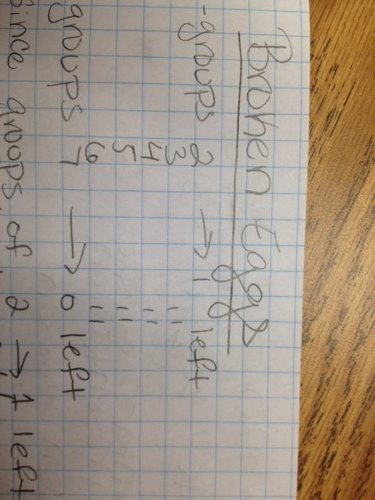
Next I examined the first entry in my list; that when the farmer put the eggs into groups of two, there was one left over. Based on that information I concluded that the number of eggs must be odd because whenever you divide an odd number by two you get a remainder of one. Similarly I analyzed the last entry in my list; that when the farmer put the eggs in groups of seven there where none left over. From this I knew that the number of eggs must be a multiple of seven. This lead me to the conjecture that $(\# eggs)=7$ since seven divides itself evenly. However, I knew there were other conditions that needed to be satisfied before I could conclude that the farmer had seven eggs. First I checked that if you group seven eggs into groups of two, there is one egg left over; so far my conjecture was correct. Next I checked the condition that when you group seven eggs into groups of three there is also one left over; this condition also held. I realized that my conjecture was false when I divided the seven eggs into groups of four and found that there were three left over instead of one.
Even though my conjecture was proved to be false, from this process I learned that not every multiple of seven will work. I also noticed that checking all of the conditions for each multiple of seven would be very time consuming. This lead me to look for constraints on the multiples of seven to narrow down the amount of numbers I would have to test. Since there is a remainder of one when the number of eggs is divided by 2,3,4,5, and 6 I know that $2,3,4,5,6 ∤(\# of eggs)$. The notion of “divides” triggered my memories of Number Theory and how useful modular arithmetic is in representing situations such as this.
I next made the conjecture that the last digit in the number of eggs must be either a one or a six. This is true because $\left(\# of eggs\right)≡1 mod 5$ and the only numbers that satisfy this congruence end in either a one or six. After adding this constraint to my list I realized that I had already proved that the number of eggs must be odd. Thus the number can not end in six; therefore the number of eggs can only end in a one. I summed up my findings by writing that the number of eggs must be a multiple of seven that ends in one. I made the following chart to organize the numbers I have tested and why or why not they could be the number of eggs the farmer had.
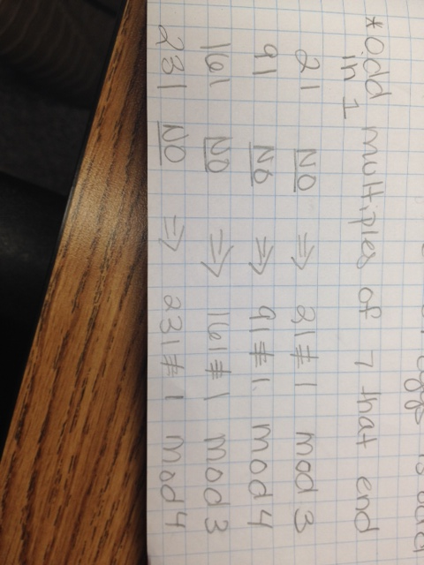
I checked the numbers in order from least to greatest. Eventually I tested the number 301 and found that
$$301≡1 mod 2$$
$$301≡1 mod 3$$
$$301≡1 mod 4$$
$$301≡1 mod 5$$
$$301≡1 mod 6$$
$$301≡0 mod 7$$
Since I proved why the numbers of eggs had to be a multiple of seven that ends in one, systematically checked these numbers in order from least to greatest, and showed that 301 satisfies all of the given conditions I concluded that 301 was the smallest number of eggs that the farmer could have been carrying. The problem asks if there are multiple possible amounts of eggs. I believe that if you continue to check numbers in this fashion, you will find other numbers that satisfy all of the conditions. Also, another student showed me that you can use the Chinese Remainder Theorem to derive an equation that yields all possible solutions to the above system of congruencies.
One way to make the problem easier would be to only have the conditions that when the farmer puts the eggs in groups of two there is one left over and that when he puts them in groups of seven there are no eggs left over. If students approach the problem in a similar fashion to how I did, this modification will allow them to find the smallest amount of eggs much quicker. To make the problem more challenging, the problem could require you to derive and prove the formula $301+420k, kϵ\left\{0, 1, 2,…\right\}$; which represents all of the possible solutions to the problem. Note that this extension requires knowledge of Number Theory. Another variation could be: A farmer loads 36 eggs onto his cart. He crashes and breaks only some of his eggs. On the ground there are 127 shell pieces from the broken eggs. Each egg broke into the same number of pieces. How many eggs where not harmed in the crash?
This was my favorite POW that we did this semester. I liked examining the given constraints and finding mathematical ways to represent them. I also liked that it was an intriguing puzzle that had multiple solutions. Furthermore, I enjoyed this problem because I could use modular arithmetic to solve it. I also liked this problem because even if someone did not know how to generalize the problem they could still test different numbers until they found one that satisfied the given conditions. Finding the first possible number of eggs was easy for me, however if I were to prove the formula that yields all other possible solutions that would make the problem more difficult. Thus this problem would be good to give to a class with a range of readiness levels.

